New to UI HealthCare? Want to be prepared for attending Regularly Scheduled CME sessions?
- Log in with your HawkID & password at https://uiowa.cloud-cme.com
- The system will prompt you to complete your profile
- You are now set to start texting or using the mobile app.

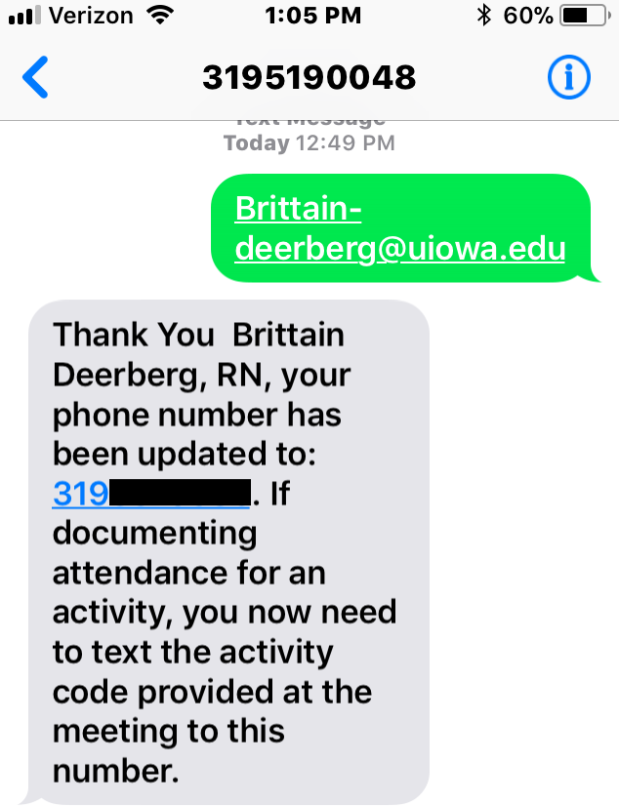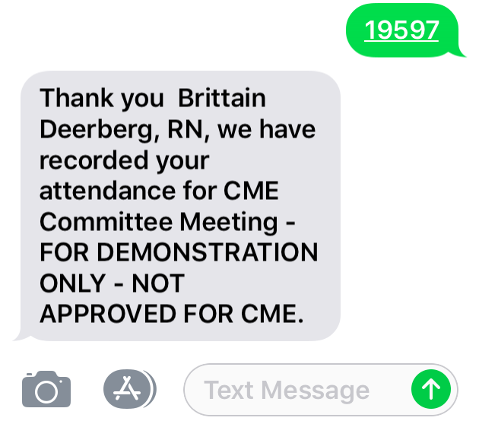

Texting Attendance
Step 1:
Text your @uiowa.edu email address to (319) 519-0048. You only need to do this one time.
Step 2:
You should receive a message that your phone number was updated.
Step 3:
Text this session’s activity code to record your attendance. Do this 15 minutes prior, during, or 60 minutes after the session ends. SMS text only (not an iMessage).
Step 4:
You should receive a confirmation that your attendance was recorded.

Cloud CME Mobile App (Android & iOS)
Step 1:  Enter your organization code: uiowa | 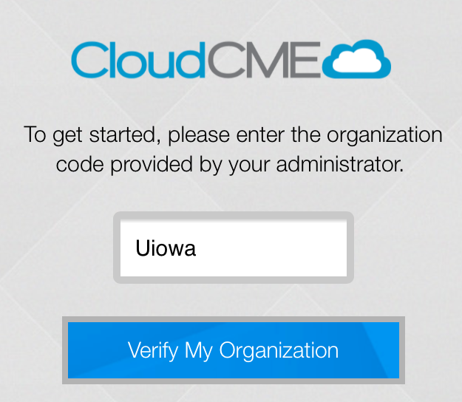
Step 2:  Sign in with your HawkID. | 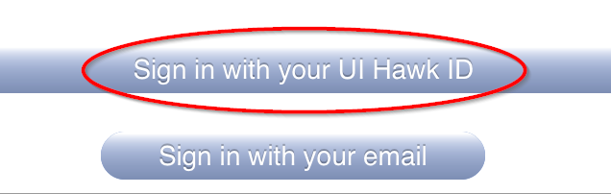
Step 3:  Select ‘My Transcript,’ ‘Calendar’ or ‘Claim Credit.’  If recording attendance, please claim credit 15 minutes prior, during, or 60 minutes after the session ends. | 