Step 1: Click on Add Content in the Gray Bar
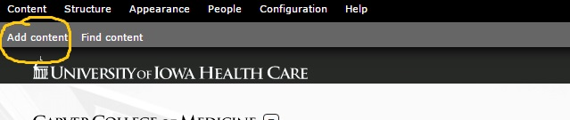

Step 2: Select Basic Page.

Step 3: Give your page a title. Consider the same title on the current CCOM page. This will show up at the top of the page.

Step 4: Enter the text into the body area. If copying the text from Microsoft Word, another website, an email, etc.use the Paste from Word.

Step 5: Assign this new page the proper menu link. This will place the page in the appropriate location within the site by indicating the Parent Item in the drop down menu. Here you also assign the weight, which will indicate the hierarchy under the Parent Item you chose. The lower the weight, the higher the page is within the hierarchy.
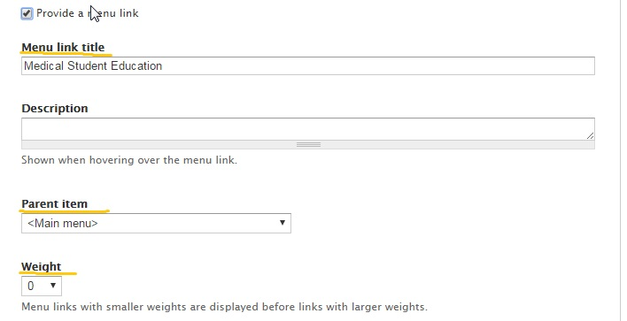

Step 6: Click save. You will now see your new page in the menu.

