Step 1: Click on News & Events (or News) in the yellow bar.

Step 2: Scroll down and find the news item you want to promote to the homepage.

Step 3: Click on the title of that news item to open that page.

Step 4: Click Edit.
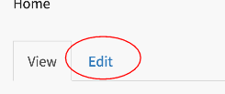

Step 5: Scroll down. Click Publishing Options.

Step 6: Click Promoted to Front Page.
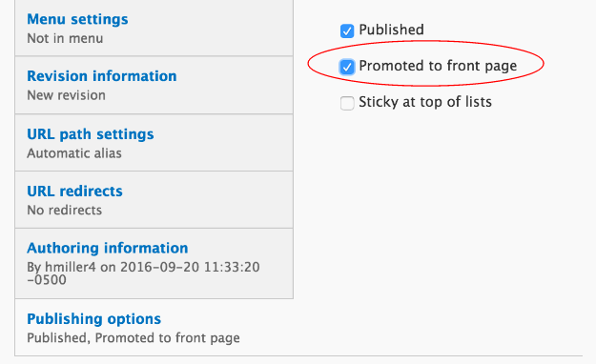

Step 7: Click Save.
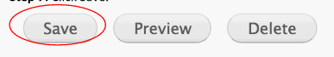

Step 8: Now to check your work. Go to the site’s landing page and make sure the article you promoted to the front page appears under news.

