Step 1: Click on Add Content in the gray bar.

Step 2: Select Slideshow Item.

Step 3: Click Browse.

Step 4: Click Choose File to select an image that is saved on your computer.
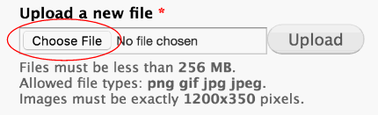

Step 5: The image must meet the size and dimension qualification to be used as a slideshow item.
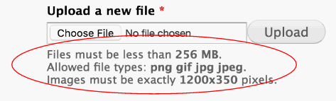

Step 6: Find the proper image on your computer and click Open.
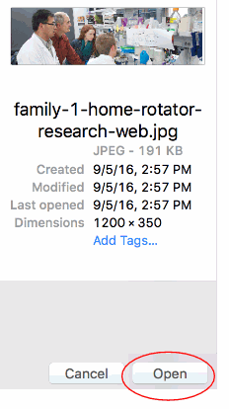

Step 7: The file name should now show up here.
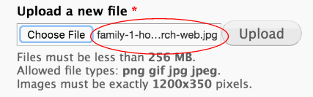

Click Next.

Step 8: Under Title Text, type the caption you wish to appear on the Slideshow item.
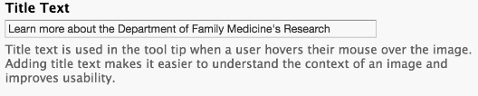

Step 9: Click Save.

Step 10: Under Title, enter the same title you previously did for the Title Text.

Step 11: Under Link, enter the proper internal (path after medicine.uiowa.edu/department/xxxx) or external link (full URL) if you wish to link the image with another within the website or another site.

***For this example we will link it with the research page.

Step 12: Click Save.
