Step 1: Click on Add Content in the gray bar.
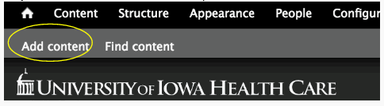

Step 2: Select Article.

Step 3: Give the article a title. This should be the same title on the current CCOM page or the actual title of the article you are creating.
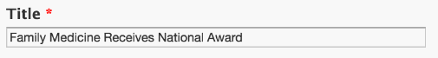

Step 4: Enter the text into the body area. If copying the text from Microsoft Word, another website, an email, etc. use the Paste from Word button.
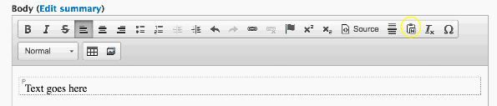

Step 5: Click on Edit Summary button. This will be the 1-2 sentence summary or the first couple sentences of the article that will show up on the news homepage.
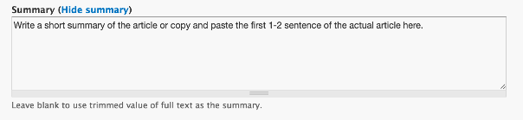

Step 6: Click Save. You will now see your news article on the news page.
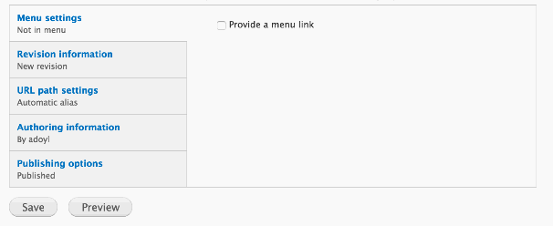

*** For news articles you do not need to provide a menu link. All articles will automatically appear on the news page.

