Step 1: Place your cursor where you want the image to appear. Then select the Add Media icon.
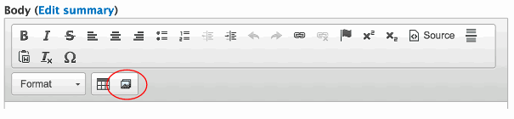

Step 2: Browse to find the file on your computer by clicking Choose File. Then click Next (it will automatically upload).
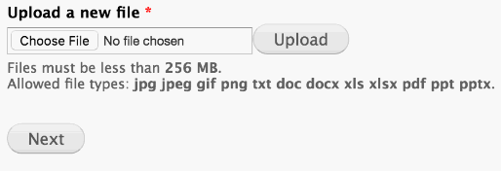

Select the Library tab If you’re uploading an existing photo that’s used on another page.

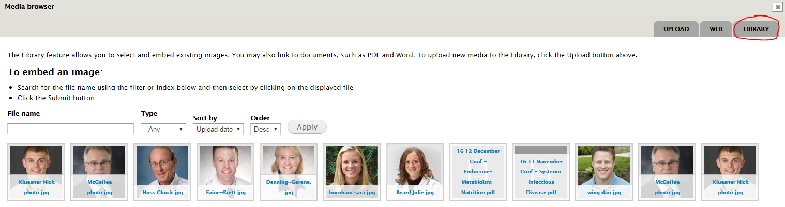

Step 3: Choose a display option and enter alt text (short description for accessibility and search engines). Title text isn’t necessary.

- Original (As uploaded) should be used if you’ve already sized your image in Photoshop.
- Large, Medium, and WYSIWYG will scale down the image.

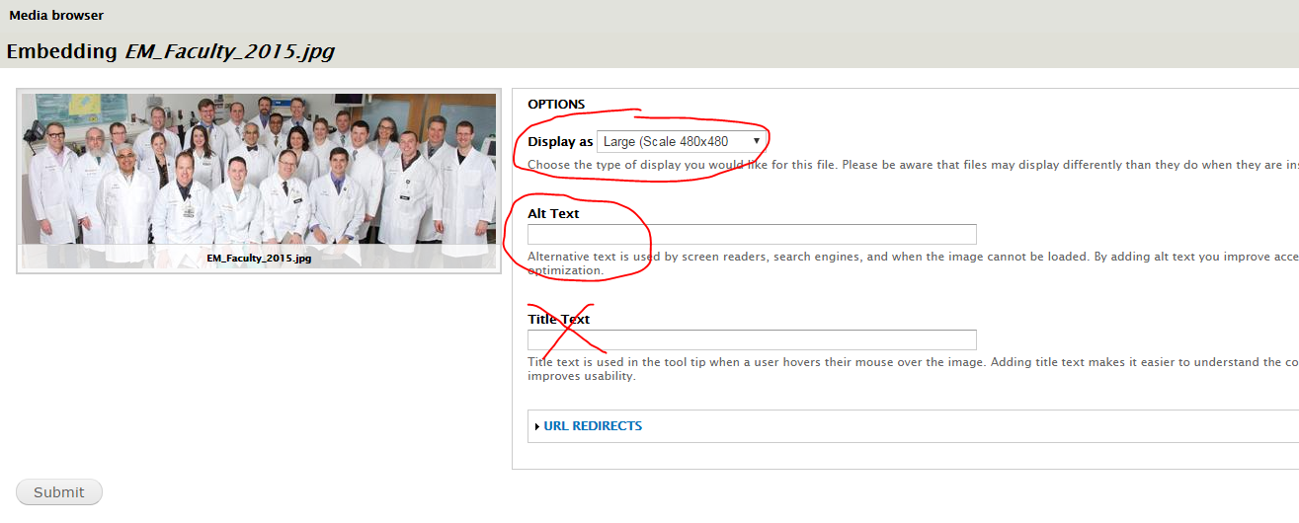

Step 4: Right click or double click on the image to adjust the properties. Enter 10 and 10 in HSpace/VSpace to add space around the photo so the text doesn’t hit the image. Choose left/right alignment. Click OK.

Note: For non-APR people listings, you may also consider a 2-column table with the necessary number of rows. Example: https://www.medicine.uiowa.edu/facilities/office-contact-information

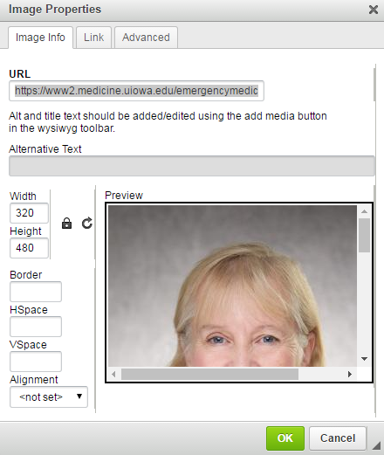

Best Practices:

- Start with a high resolution photo from WebDam, Flickr, Google Image search (labeled for reuse), Pexels, etc. Then crop in Photoshop to the size you want.
- Body copy images generally should not exceed 300 px wide.
- Use lowercase filenames with hyphens (-) or underscores (_).

