WebDam
Photos by Susan McCellan; managed by UIHC Marketing & Communications

https://uihealthcare.webdamdb.com
jamie-jones@uiowa.edu
Ccomwgs2016!

- Search by keyword or folder.
- Click on the photo you want to download.
- Then click on the Download button.
- Choose the highest resolution. Then size down/crop in Photoshop.
- This login is not linked to Jamie’s Healthcare ID in any way :)

UI Photo Shelter
Photos by UI Office of Strategic Communications photographers

http://uiowa.photoshelter.com/index
Click “Login” on the top black bar to access Invited Galleries

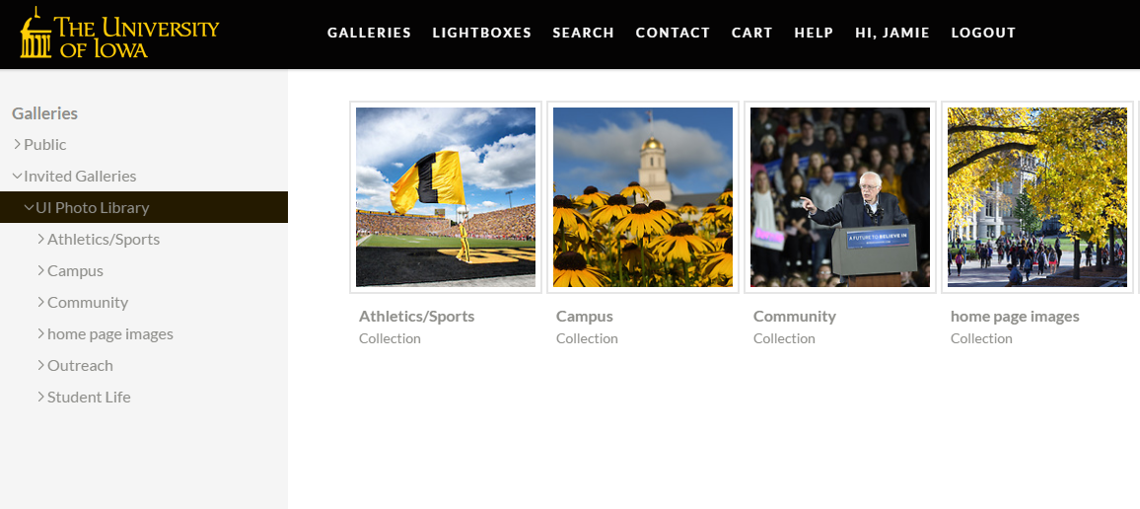

UIHC Flickr

Photostream: https://www.flickr.com/photos/uihealthcare/ (most recent uploads)
Albums: https://www.flickr.com/photos/uihealthcare/albums

- Click on the photo you want to download.
- Then click on the download button in the lower right corner.
- Select Original, which is the highest resolution. Then size down/crop in Photoshop.

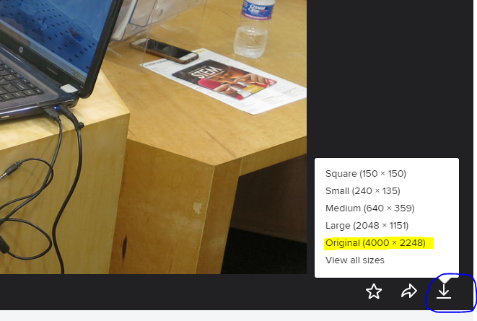

Pexels
Free stock photos

https://www.pexels.com

- Search by keyword.
- Click on the photo you want to download.
- Click on the Free Download button. Select Original, which is the highest resolution. Then size down/crop in Photoshop.

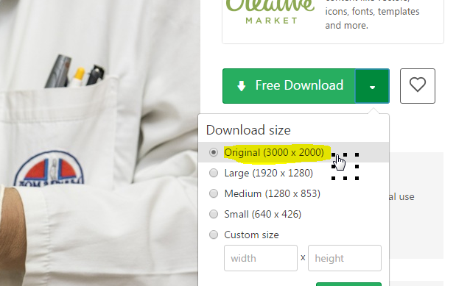

Google Image Search

- Go to Google and type in a keyword.
- Click Images > Search tools > Usage rights > Labeled for reuse.
- Hover over a photo to see its size.
- Click on the photo > View Image. Then right click to “Save image as…” (different options based on browser). Save to your computer.
- See screenshots below.

Note: Most of Google’s open photos are from Wikipedia/Wikimedia Commons. They have a huge selection!
