Step 1: The PDF should reside somewhere on your computer. Name your PDF using lowercase words and dashes (-) or underscores (_) rather than spaces.

Step 2: Go to the page where you want to add the PDF, and click the Edit tab.

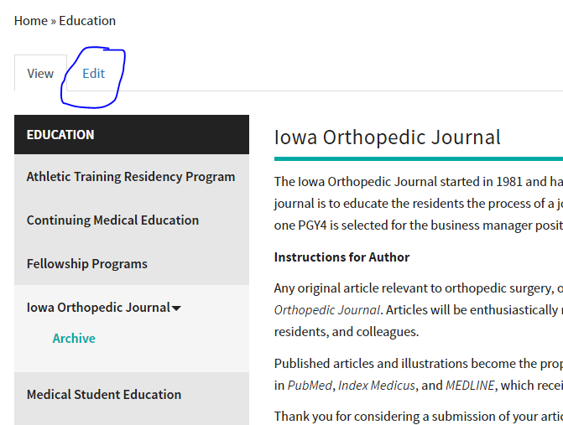

Step 3: Click into the body area where you want the PDF to appear, and then select the the Add Media button.

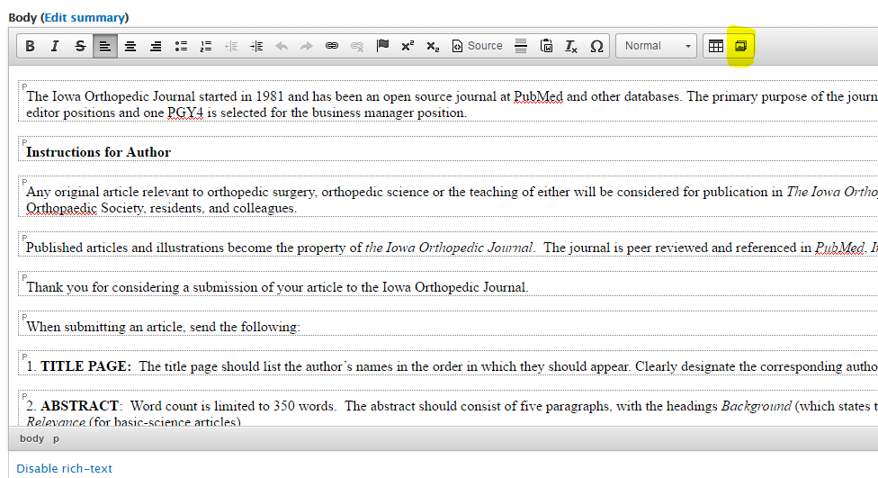
Step 4: Browse to find the PDF file on your computer. Click Upload, then Next. Alt Text and Title Text are not needed. Click Save, then Submit. No need to change anything under Options.

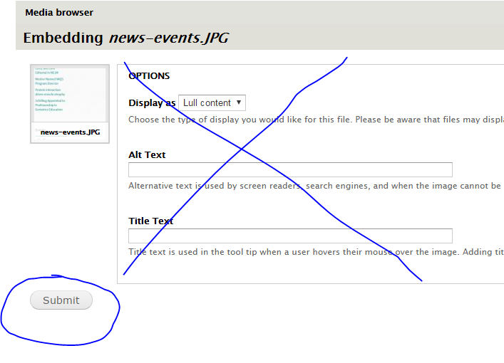

Step 5: Your PDF - with the filename you gave it - will appear on your page.

Step 6: Double click on the PDF and copy the URL.

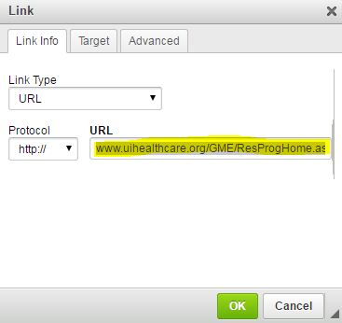
Step 7: Go back to editing your page. Retype the link text as you want it to appear, highlight it, and then link it. Paste the PDF URL that you just copied. Open in a new tab/window in the Target tab, and then click Ok. Save your page.

