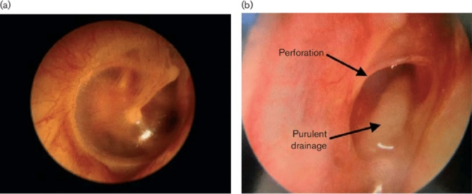
ENT INterest GROUP of

UNIVERSITY OF IOWA

  - OTOSCOPIC SIMULATION

Faculty Mentor

Sohit Paul Kanotra

Department of Otolaryngology

Cash Prizes Winning Trophy

February 18th , 2020
Merf 1185 at 12pm-1pm
Lunch will be provided

Please RSVP to yixi-wang@uiowa.edu

