Step 1: Click Structure in the Black Bar.

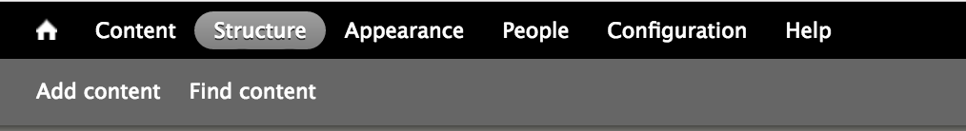

Step 2: Click Menus.

Step 3: Click List Links under Main Menu.
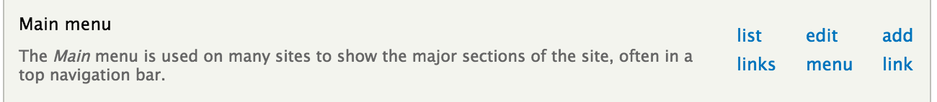

Step 4: Click Add Link.

Step 5: Under Menu Link Title, type the text you wish to appear in the sidebar/menu hierarchy.
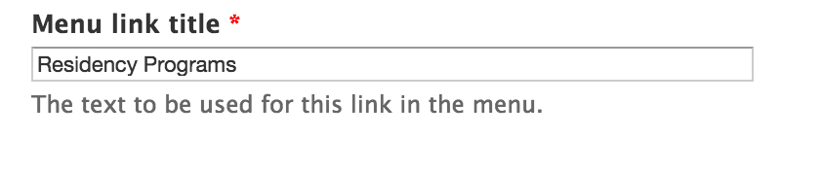

Step 6: Under Path, enter the URL or correct internal link.
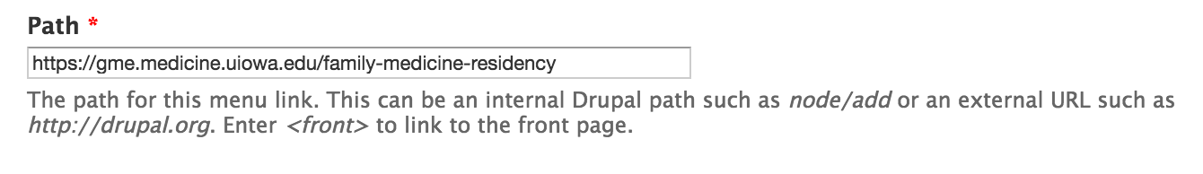

Step 7: Scroll down to Parent Link. Select the correct parent item so the menu item is properly placed within the site.
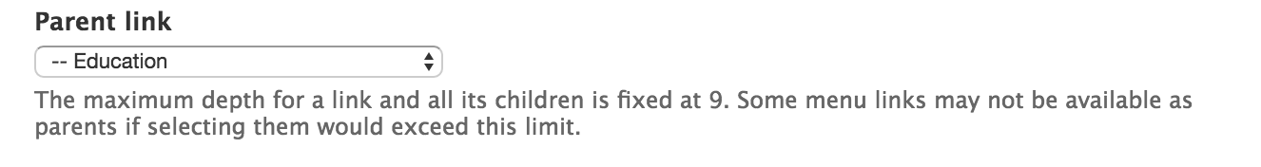

Step 8: Under Weight, select the proper weight number to determine to location/hierarchy of this menu item.
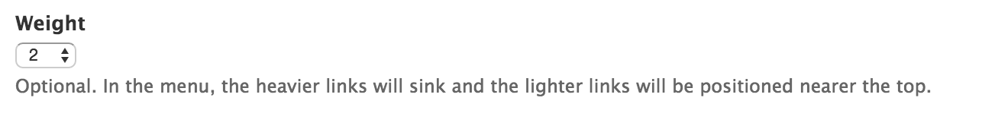
**Remember, the lower the weight number, the higher up/closer to the top the menu item will appear.

Step 9: Click Save. The menu item should now appear within the structure of the site.

Step 10: After you click save, the site will take you back to the site’s structure. Scroll down and ensure your menu item is in the correct placement. If not, you can drag/drop to the appropriate location.
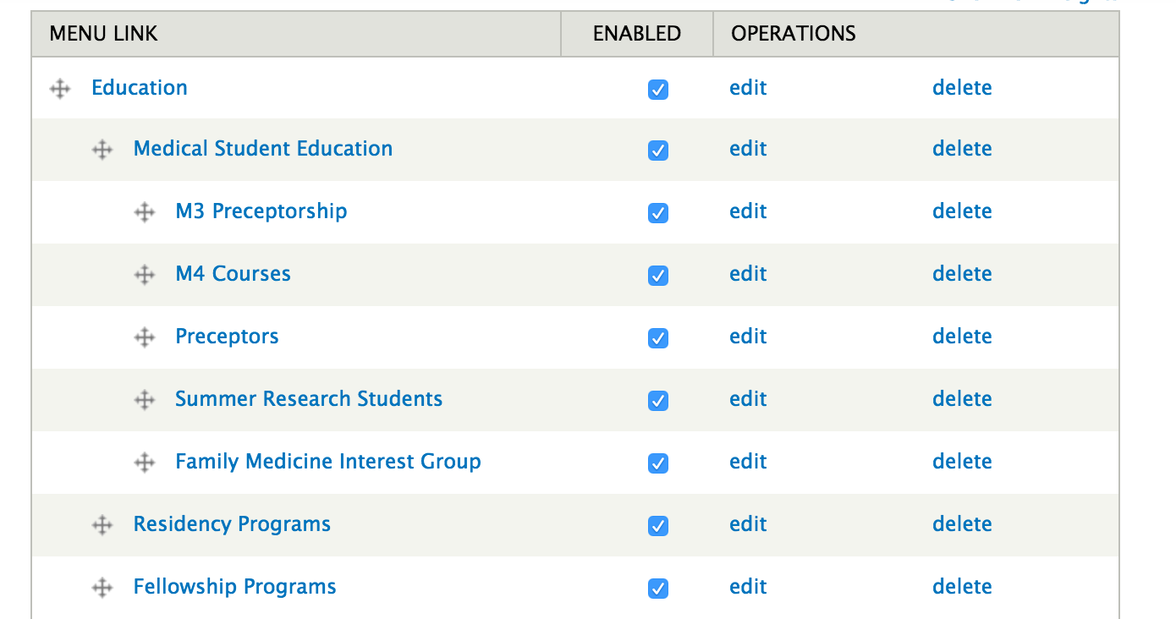

Step 11: To check if your link is working correctly, go back to the site and find your new menu item. Click on the menu item.

