Step 1: Click Add Content in the gray bar.
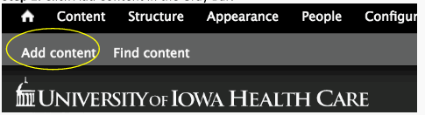

Step 2: Select Spotlight Items.
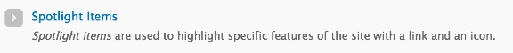

Step 3: Under Title, type the correct name of the Spotlight Item (Meet Our Team, Education, Research, Support Our Department, etc.)

Step 4: Under Icon, type the correct code for the icon you wish to represent the title. There is a PDF document containing a list of the icon codes name Icon Library Codes.

***For this example we used the code fa-book to represent Education.
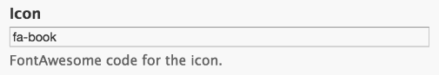

Step 5: Under Teaser Text, type or copy a short description that you wish to appear under the icon on the site’s landing page.
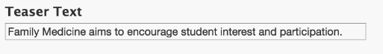

Step 6: Under Link, type or copy the proper internal or external link you wish to link up with the Spotlight Item.

***For this example we will link it with the education homepage.

Step 7: Click Save.
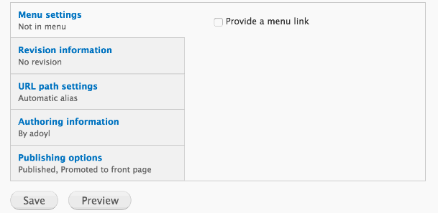

Step 8: To check if everything went correctly, go to the site’s landing page and make sure you see the correct title, icon, and teaser text. To check if the link worked correctly, click on the title and see if it takes you to the correct location.

