Step 1: Create your new page, save it, and then copy the URL of the published page.

Step 2: Click Structure > Menus.
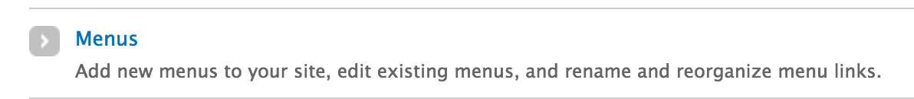

Step 3: Click List Links under Main Menu.
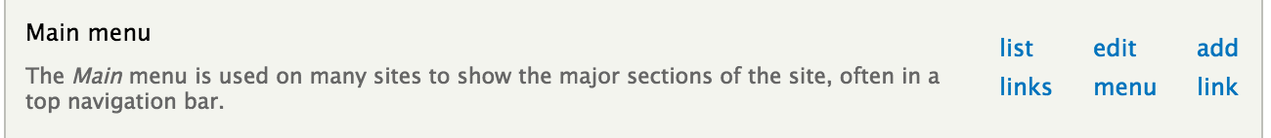

Step 4: Uncheck the box for that page to hide it from the menu, and Save Configuration. This will make your page invisible from the menu structure, but your URL is still active.

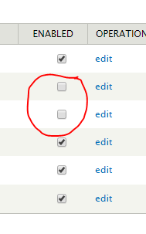
Step 5: Check the box to re-enable the page when you’re ready.

