You have four options for links:

Internal path = any page within your site
URL = any external website (ex: uihealthcare.org, gme.medicine.uiowa.edu, uiowa.edu, aamc.org)

Link to anchor in the text = for longer pages that jump down to a section (not recommended unless absolutely necessary - see example)

E-mail = a person’s e-mail address

Internal Path Example

Step 1: Highlight the text you want to link, and then click the Link (chain) icon.

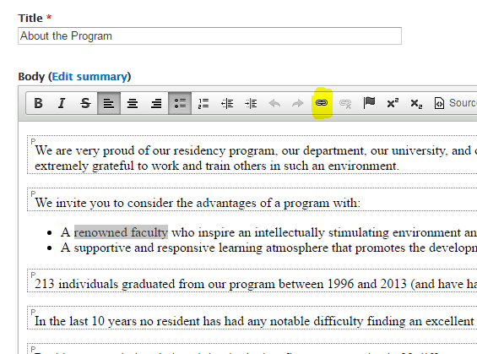

Step 2: Open a new tab of the page you want to link the text to.
Step 3: Once you get to the page you want to link the text to, click Edit.

Step 3: Scroll down and click URL Path Settings.
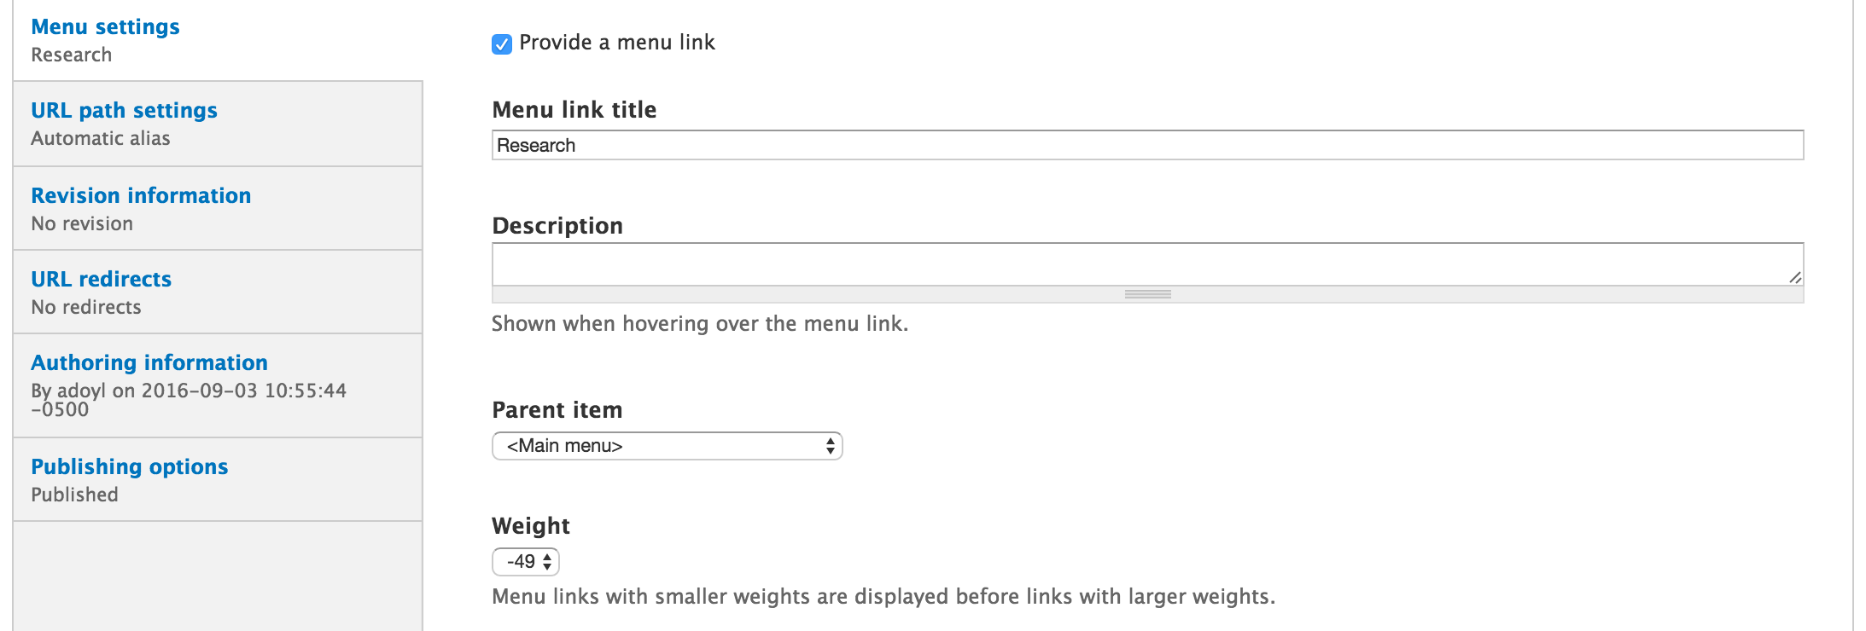

Step 4: Copy the URL Alias.
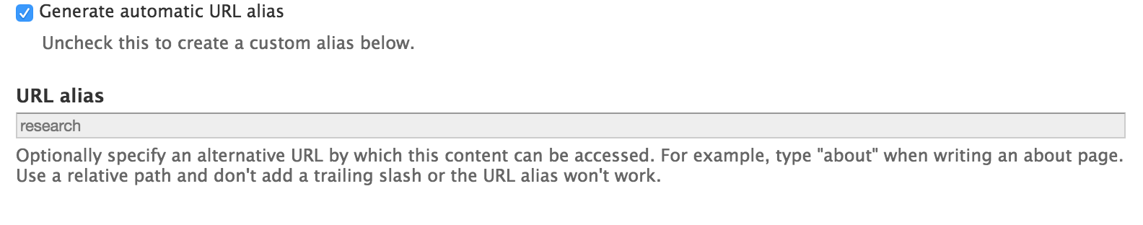

Step 5: Go back to the original page that is ready to add a link. It should look like this.
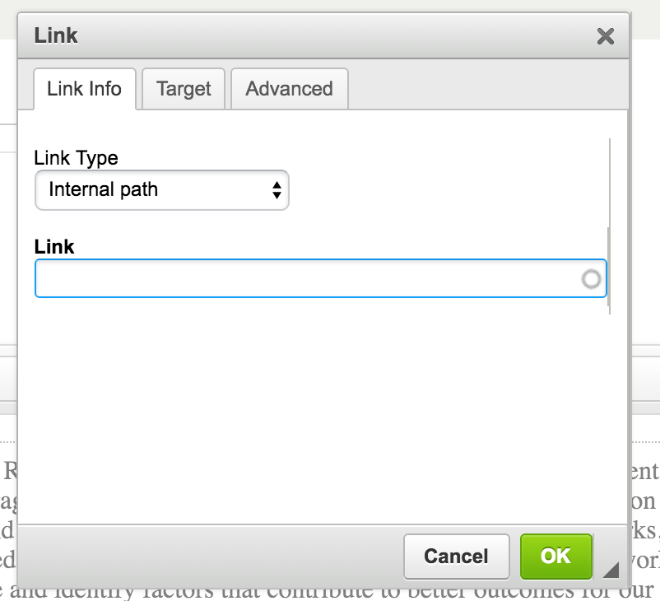

Step 6: Under Link, paste the link from the other page.
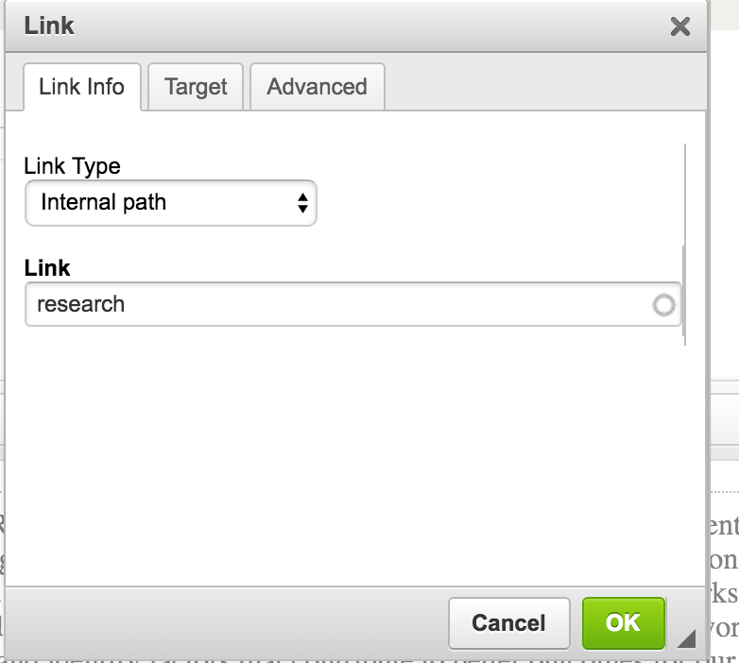

Step 7: Click OK.

Step 8: The Link should appear within the body of text.

Step 9: Scroll down and save the page.

URL Example

Step 1: Highlight the text you want to link, and then click the Link (chain) icon

Step 2: Go the external page you want to link to by opening a new tab in your browser. Copy the full URL.

Step 3: Go back to the page you’re editing and make sure that URL is selected from the Link Type drop-down. Then paste your external URL into the URL field. Click OK, and your link will appear. Be sure to save your page.

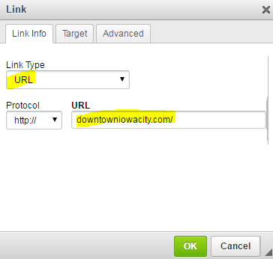

E-mail Example

Step 1: Highlight the text you want to link, and then click the Link (chain) icon.

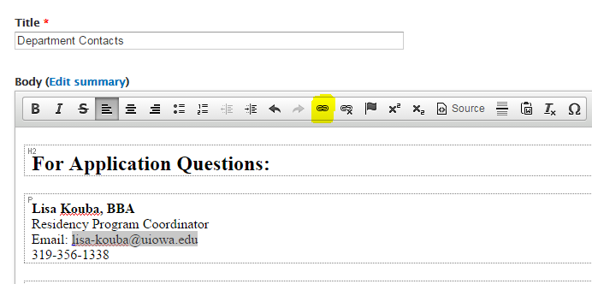

Step 2: Choose E-mail from the Link Type drop-down. Then type or copy the person’s e-mail address as seen below. Click OK and your link will appear. Be sure to save your page.

