Linking to your department’s APR profiles

Step 1: Go to the Page within the site you want to link a profile to.

Step 2: Click Edit.

Step 3: Highlight the name of the person you want to link and click on the link icon.
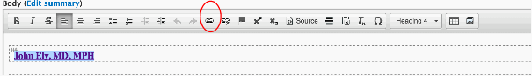

Step 4: The link info should be Internal Path.
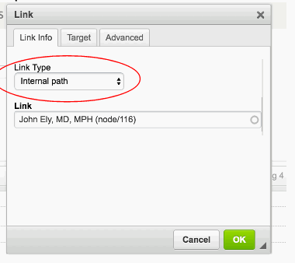

Step 5: Start typing the person’s name until the correct person shows up underneath. Click on the person’s name so it shows up in the Link Box.
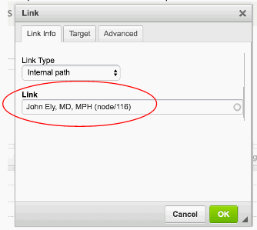
Step 6: Click OK.
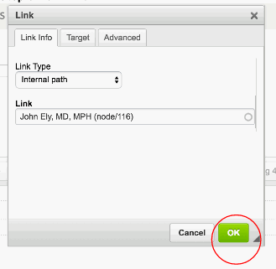

Step 7: Scroll down and click Save.

Linking to another department’s APR profiles

Step 1: Go to the department site where the person’s APR profile resides (generally under People > Primary/Secondary Faculty). Click on the profile, and copy the URL.

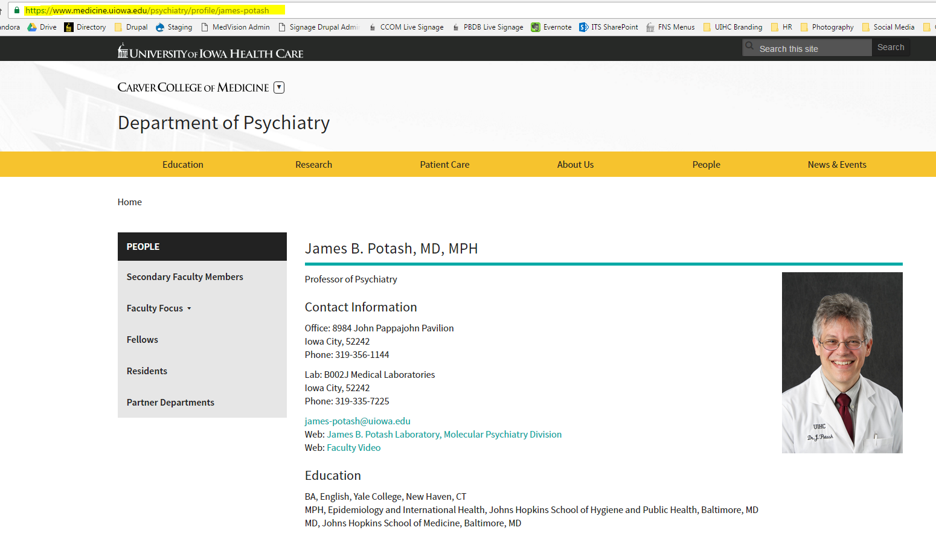

Step 2: Go back to your site, highlight the text you want to link, and enter the URL. Open in a new window through the Target tab.

